Lab 12: Function

# Name: Hassan Shahzad

# Class: BSCS 7C

# CMS ID: 211798

## Task 01:

#define _CRT_SECURE_NO_WARNINGS

#include <stdio.h>

#include <stdlib.h>

void butterfly();

void elephant();

void teddybear();

void snake();

int main()

{

int choice;

printf( "1. Butterfly \n" );

printf( "2. Elephant \n" );

printf( "3. Teddy Bear\n" );

printf( "4. Snake \n" );

// asking which animal to be drawn

printf( "\nWhich animal to draw? " );

scanf( "%d", &choice );

printf( "\n" );

if ( choice == 1 ) // displays butterfly

{

butterfly();

butterfly();

//Q1): By writing another time butterfly two times butterfly is printed

}

else if ( choice == 2 ) // displays elephant

{

elephant();

}

else if ( choice == 3 ) // displays teddybear

{

teddybear();

}

else if ( choice == 4 ) //displays snake

{

snake();

}

else // if otherthan above options were chosen

{

printf( "Sorry, that wasn't one of the choices.\n" );

}

printf( "\nGoodbye!\n" );

return EXIT_SUCCESS;

}

void butterfly() // butterfly function

{

printf(" .==-. .-==. \n");

printf(" \\()8`-._ `. .' _.-'8()/ \n");

printf(" (88\" ::. \\./ .:: \"88) \n");

printf(" \\_.'`-::::.(#).::::-'`._/ \n");

printf(" `._... .q(_)p. ..._.' \n");

printf(" \"\"-..-'|=|`-..-\"\" \n");

printf(" .\"\"' .'|=|`. `\"\". \n");

printf(" ,':8(o)./|=|\\.(o)8:`. \n");

printf(" (O :8 ::/ \\_/ \\:: 8: O) \n");

printf(" \\O `::/ \\::' O/ \n");

printf(" \"\"--' `--\"\" \n");

}

void elephant() // elephant function

{

printf(" _..--\"\"-. .-\"\"--.._ \n");

printf(" _.-' \\ __...----...__ / '-._ \n");

printf(" .' .:::...,' ',...:::. '. \n");

printf("( .'``'''::; ;::'''``'. )\n");

printf(" \\ '-) (-' /\n");

printf(" \\ / \\ /\n");

printf(" \\ .'.-. .-.'. / \n");

printf(" \\ | \\0| |0/ | / \n");

printf(" | \\ | .-==-. | / | \n");

printf(" \\ `/`; ;`\\` / \n");

printf(" '.._ (_ | .-==-. | _) _..' \n");

printf(" `\"`\"-`/ `/' '\\` \\`-\"`\"` \n");

printf(" / /`; .==. ;`\\ \\ \n");

printf(" .---./_/ \\ .==. / \\ \\ \n");

printf(" / '. `-.__) | `\" \n");

printf(" | =(`-. '==. ; \n");

printf(" \\ '. `-. / \n");

printf(" \\_:_) `\"--.....-' \n");

}

void teddybear() // teddybear function

{

printf(" ___ .--. \n");

printf(" .--.-\" \"-' .- | \n");

printf(" / .-,` .' \n");

printf(" \\ ` \\ \n");

printf(" '. ! \\ \n");

printf(" | ! .--. | \n");

printf(" \\ '--' /.____ \n");

printf(" /`-. \\__,'.' `\\ \n");

printf(" __/ \\`-.____.-' `\\ / \n");

printf(" | `---`'-'._/-` \\----' _ \n");

printf(" |,-'` / | _.-' `\\ \n");

printf(" .' / |--'` / | \n");

printf(" / /\\ ` | | \n");

printf(" | .\\/ \\ .--. __ \\ |\n");

printf(" '-' '._ / `\\ / \n");

printf(" `\\ ' |------'` \n");

printf(" \\ | | \n");

printf(" \\ / \n");

printf(" '._ _.' \n");

printf(" `` \n");

}

void snake() // snake function

{

printf(" ,,'6''-,. \n");

printf(" <====,.;;--. \n");

printf(" _`---===. \"\"\"==__ \n");

printf(" //\"\"@@-\\===\\@@@@ \"\"\\\\ \n");

printf(" |( @@@ |===| @@@ || \n");

printf(" \\\\ @@ |===| @@ // \n");

printf(" \\\\ @@ |===|@@@ // \n");

printf(" \\\\ |===| // \n");

printf("___________\\\\|===| //_____,----\"\"\"\"\"\"\"\"\"\"-----,_ \n");

printf(" \"\"\"\"---,__`\\===`/ _________,---------,____ `, \n");

printf(" |==|| `\\ \\ \n");

printf(" |==| | pb ) | \n");

printf(" |==| | _____ ______,--' ' \n");

printf(" |=| `----\"\"\" `\"\"\"\"\"\"\"\" _,-'\n");

printf(" `=\\ __,---\"\"\"-------------\"\"\"'' \n");

printf(" \"\"\"\" \n");

}

## Output:

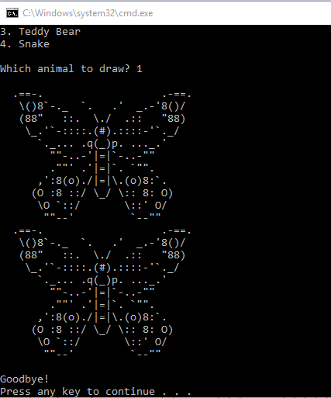

## Task 02:

#include <stdio.h>

#include <stdlib.h>

#include <time.h>

void first();

void second();

void third();

void fourth();

void fifth();

void delay( int );

int getNextRand();

int main()

{

srand (time(NULL)); // initialize random seed

int r;

for ( int i=0; i<100000; i++ ) // loops executes 100000 times

{

r = getNextRand(); // generates random number

if (r == 1)

first();

if (r == 2)

second();

if (r == 3)

third();

if (r == 4)

fourth();

if (r == 5)

fifth();

delay(300); //delay of 300

}

printf("Practice is the best of all instructors.\r");

return EXIT_SUCCESS;

}

// declaring function prototypes

void first()

{

printf("Practice .\r");

}

void second()

{

printf(" is the .\r");

}

void third()

{

printf(" best .\r");

}

void fourth()

{

printf(" of all .\r");

}

void fifth()

{

printf(" instructors.\r");

}

int getNextRand()

{

return 1 + rand() % 5;

}

void delay(int milliseconds)

{

long pause;

clock_t now, then;

pause = milliseconds * (CLOCKS_PER_SEC/1000);

now = then = clock();

while( (now - then) < pause )

now = clock();

}

## Output:

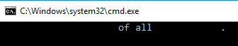

## Task 03:

#include <stdio.h>

#include <stdlib.h>

#include <math.h>

double triangleArea( int a, int b, int c ); // function call

int main()

{

double a;

a = triangleArea(3, 3, 3);

printf("A triangle with sides 3,3,3 has an area of %.2f\n", a );

a = triangleArea(3, 4, 5);

printf("A triangle with sides 3,4,5 has an area of %.2f\n", a );

a = triangleArea(7, 8, 9);

printf("A triangle with sides 7,8,9 has an area of %.2f\n", a );

printf("A triangle with sides 5,12,13 has an area of %.2f\n", triangleArea(5, 12, 13) );

printf("A triangle with sides 10,9,11 has an area of %.2f\n", triangleArea(10, 9, 11) );

printf("A triangle with sides 8,15,17 has an area of %.2f\n", triangleArea(8, 15, 17) );

printf("A triangle with sides 9,9,9 has an area of %.2f\n", triangleArea(9, 9, 9));

}

double triangleArea( int a, int b, int c ) // function prototype

{

// the code in this function computes the area of a triangle whose sides have lengths a, b, and c

double s, A;

s = (a+b+c) / 2.0;

A = sqrt( s*(s-a)*(s-b)*(s-c) );

return A;

// ^ after computing the area, "return" it

}

// Q1) Both of the programs give the same output.

// Q2) Herons formula have 33 lines. Herons Formulas No function has 51 lines.

// Q3) It was quite easier for the file containing functions

// Q4) No it was easier.

## Output:

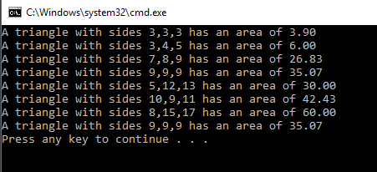

## Task 04:

#include <stdio.h>

#include <stdlib.h>

#include <math.h>

double distance( int x1, int y1, int x2, int y2 );

int main()

{

double d1 = distance(-2,1 , 1,5);

printf(" (-2,1) to (1,5) => %.2lf\n", d1 );

double d2 = distance(-2,-3 , -4,4);

printf(" (-2,-3) to (-4,4) => %.2lf\n", d2 );

printf(" (2,-3) to (-1,-2) => %.2lf\n", distance(2,-3,-1,-2) );

printf(" (4,5) to (4,5) => %.2lf\n", distance(4,5,4,5) );

return EXIT_SUCCESS;

}

double distance( int x1, int y1, int x2, int y2 ) // function prototype

{

double d = sqrt((x2-x1)*(x2-x1) + (y2-y1)*(y2-y1)); // distance formula

return d;

}

## Output:

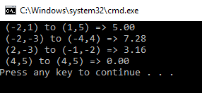

## Task 05:

#include <stdio.h>

void january();

void february();

void march();

void april();

void may();

void june();

void july();

void august();

void september();

void october();

void november();

void december();

void anymonthelse();

int main()

{

printf("Month 1: ");

january(); // function call

printf("\n");

printf("Month 2: ");

february(); // function call

printf("\n");

printf("Month 3: ");

march(); // function call

printf("\n");

printf("Month 4: ");

april(); // function call

printf("\n");

printf("Month 5: ");

may(); // function call

printf("\n");

printf("Month 6: ");

june(); // function call

printf("\n");

printf("Month 7: ");

july(); // function call

printf("\n");

printf("Month 8: ");

august(); // function call

printf("\n");

printf("Month 9: ");

september(); // function call

printf("\n");

printf("Month 10: ");

october(); // function call

printf("\n");

printf("Month 11: ");

november(); // function call

printf("\n");

printf("Month 12: ");

december(); // function call

printf("\n");

printf("Month 43: ");

anymonthelse();

printf("\n");

}

// function prototypes

void january()

{

printf("January");

}

void february()

{

printf("February");

}

void march()

{

printf("March");

}

void april()

{

printf("April");

}

void may()

{

printf("May");

}

void june()

{

printf("June");

}

void july()

{

printf("July");

}

void august()

{

printf("August");

}

void september()

{

printf("September");

}

void october()

{

printf("October");

}

void november()

{

printf("November");

}

void december()

{

printf("December");

}

void anymonthelse()

{

printf("ERROR\n");

}

## Output:

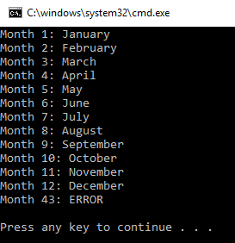

## Task 06:

#include <stdio.h>

#include <stdlib.h>

int month_offset(int); // prototype

int main()

{

printf("Offset for month 1: %d\n", month_offset(1));

printf("Offset for month 2: %d\n", month_offset(2));

printf("Offset for month 3: %d\n", month_offset(3));

printf("Offset for month 4: %d\n", month_offset(4));

printf("Offset for month 5: %d\n", month_offset(5));

printf("Offset for month 6: %d\n", month_offset(6));

printf("Offset for month 7: %d\n", month_offset(7));

printf("Offset for month 8: %d\n", month_offset(8));

printf("Offset for month 9: %d\n", month_offset(9));

printf("Offset for month 10: %d\n", month_offset(10));

printf("Offset for month 11: %d\n", month_offset(11));

printf("Offset for month 12: %d\n", month_offset(12));

printf("Offset for month 43: %d\n", month_offset(43));

return EXIT_SUCCESS;

}

int month_offset(int month)

{

int result;

if (month == 1)

{

result = 1;

return result;

}

else if (month == 2)

{

result = 4;

return result;

}

else if (month == 3){

result = 4;

return result;

}

else if (month == 4){

result = 0;

return result;

}

else if (month == 5){

result = 2;

return result;

}

else if (month == 6){

result = 5;

return result;

}

else if (month == 7){

result = 0;

return result;

}

else if (month == 8){

result = 3;

return result;

}

else if (month == 9){

result = 6;

return result;

}

else if (month == 10){

result = 1;

return result;

}

else if (month == 11){

result = 4;

return result;

}

else if (month == 12){

result = 6;

return result;

}

else{

result = -1;

return result;

}

}

## Output:

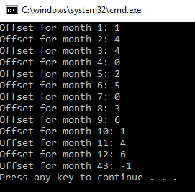

## Task 07:

#define _CRT_SECURE_NO_WARNINGS

#include <stdio.h>

#include <stdlib.h>

double triangle();

int rectangle();

int square();

double circle();

int main()

{

int choice;

while (1)

{

printf("Shape Area Calculator\n\n");

printf("-=-=-=-=-=-=-=-=-=-=-=-=-=-=-=-=-=-=-=-=-=-=\n\n");

printf("1) Triangle \n2) Rectangle\n3) Square\n4) Circle\n5) Quit\n");

printf("Which Shape: ");

scanf("%d", &choice);

if (choice == 1)

{

int base, height;

printf("Base: ");

scanf("%d", &base);

printf("Height: ");

scanf("%d", &height);

triangle(base, height);

}

if (choice == 2)

{

int length, width;

printf("Length: ");

scanf("%d", &length);

printf("Width: ");

scanf("%d", &width);

rectangle(length, width);

}

if (choice == 3)

{

int side_length;

printf("Side Length: ");

scanf("%d", &side_length);

square(side_length);

}

if (choice == 4)

{

int radius;

printf("Radius: ");

scanf("%d", &radius);

circle(radius);

}

if (choice == 5)

{

return 0;

}

}

}

double triangle(int base, int height)

{

float area;

area = 0.5 * base * height;

printf("Area: %.2f\n", area);

return area;

}

int rectangle(int length, int width)

{

int area;

area = length * width;

printf("Area: %d\n", area);

return area;

}

int square(int side_length)

{

int area;

area = side_length * 4;

printf("Area: %d\n", area);

return area;

}

double circle(int radius)

{

float area;

area = 3.14 * radius * radius;

printf("Area: %.2f\n", area);

return area;

}

## Output:

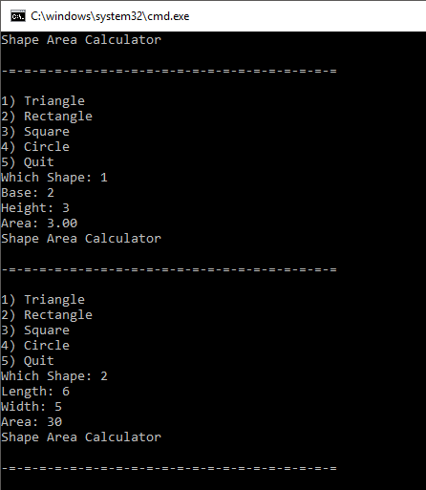

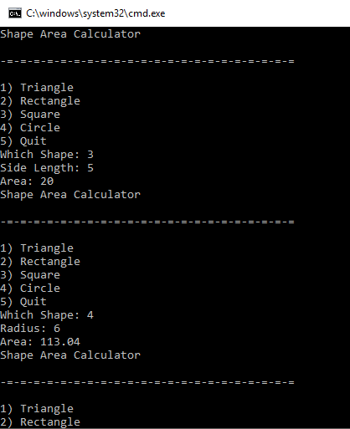

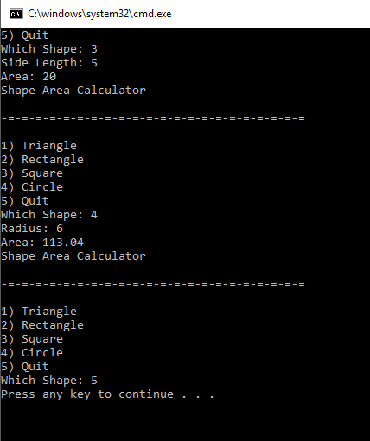

## Task 08:

#define _CRT_SECURE_NO_WARNINGS

#include <stdio.h>

#include <stdlib.h>

void add_keychains();

void remove_keychains();

void view_order();

int checkout();

int main()

{

while (1)

{

int choice;

printf("Old Keychain Shop\n\n");

printf("1. Add keychains to order.\n2. Remove Keychains from order.\n3. View Current Order. \n4. Checkout.\n");

printf("\nPlease enter your choice: ");

scanf("%d", &choice);

if (choice == 1)

add_keychains();

if (choice == 2)

remove_keychains();

if (choice == 3)

view_order();

if (choice == 4){

checkout();

return EXIT_SUCCESS;

}

}

}

void add_keychains()

{

printf("ADD KEYCHAINS\n\n");

}

void remove_keychains()

{

printf("REMOVE KEYCHAINS\n\n");

}

void view_order()

{

printf("VIEW ORDER\n\n");

}

int checkout()

{

printf("CHECKOUT\n\n");

}

## Output:

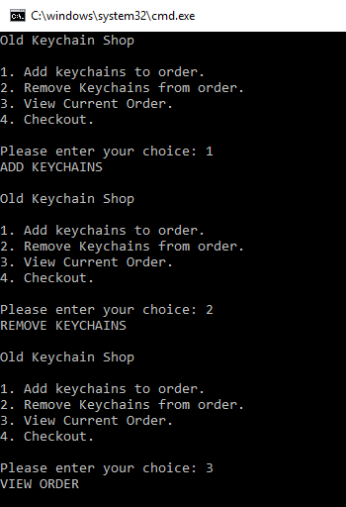

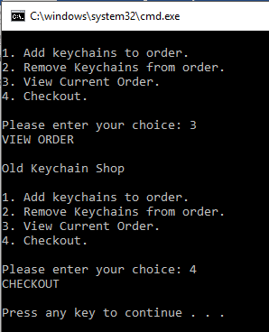

## Task 09:

#define _CRT_SECURE_NO_WARNINGS

#include <stdio.h>

#include <stdlib.h>

#include <string.h>

int add_keychains();

int remove_keychains();

int view_order();

int checkout();

int current_keys = 0, price_per_keychain = 50, totalprice = 0;

int main()

{

char name[20];

while (1)

{

int choice;

printf("Old Keychain Shop\n\n");

printf("1. Add keychains to order.\n2. Remove Keychains from order.\n3. View Current Order. \n4. Checkout.\n");

printf("\nPlease enter your choice: ");

scanf("%d", &choice);

if (choice == 1)

add_keychains();

if (choice == 2)

remove_keychains();

if (choice == 3)

view_order();

if (choice == 4)

{

checkout();

printf("What is your name? ");

scanf("%s", &name);

printf("You have %d keychains.\n", current_keys);

printf("Total Cost is Rs.%d\n", totalprice);

printf("Thanks for your order, %s\n", name);

return 0;

}

}

}

int add_keychains()

{

int keys_added;

printf("You have %d keychains. How many to add? ", current_keys);

scanf("%d", &keys_added);

current_keys = current_keys + keys_added;

printf("You now have %d keychains.\n\n", current_keys);

return current_keys;

}

int remove_keychains()

{

int keys_removed;

printf("You have %d keychains. How many to remove? ", current_keys);

scanf("%d", &keys_removed);

current_keys = current_keys - keys_removed;

printf("You now have %d keychains. \n\n", current_keys);

return current_keys;

}

int view_order()

{

printf("Keychain costs Rs. 50 each.\n");

totalprice = totalprice + (current_keys * price_per_keychain);

printf("Total Cost is: %d\n\n", totalprice);

return totalprice;

}

int checkout()

{

printf("CHECKOUT\n\n");

}

## Output:

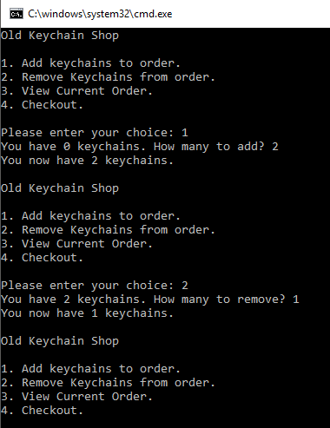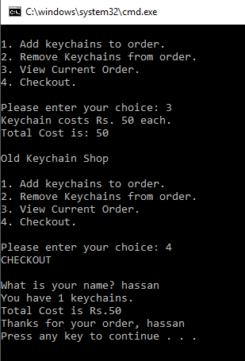

## Task 10:

#define _CRT_SECURE_NO_WARNINGS

#include <stdio.h>

#include <stdlib.h>

#include <string.h>

int add_keychains();

int remove_keychains();

void view_order(int, int, double, int, int);

void checkout(int, int, double, int, int);

int current_keys = 0, price_per_keychain = 50, totalprice = 0;

double finaltotal;

char name[20];

int main()

{

int choice;

double sales_tax = 0.825;

int shipping_cost = 10;

int per_keychain_shipping = 20;

do

{

printf("Old Keychain Shop\n\n");

printf("1. Add keychains to order.\n2. Remove Keychains from order.\n3. View Current Order. \n4. Checkout.\n");

printf("\nPlease enter your choice: ");

scanf("%d", &choice);

if (choice == 1)

add_keychains();

if (choice == 2)

remove_keychains();

if (choice == 3)

view_order(shipping_cost, per_keychain_shipping, sales_tax, price_per_keychain, current_keys);

if (choice == 4)

{

checkout(shipping_cost, per_keychain_shipping, sales_tax, price_per_keychain, current_keys);

return 0;

}

if (choice != 1 && choice != 2 && choice != 3 && choice != 4)

printf("Invalid Input. Try Again\n");

} while (choice != 4);

}

int add_keychains()

{

int keys_added;

printf("You have %d keychains. How many to add? ", current_keys);

scanf("%d", &keys_added);

current_keys = current_keys + keys_added;

printf("You now have %d keychains.\n\n", current_keys);

return current_keys;

}

int remove_keychains()

{

int keys_removed;

printf("You have %d keychains. How many to remove? ", current_keys);

scanf("%d", &keys_removed);

current_keys = current_keys - keys_removed;

printf("You now have %d keychains. \n\n", current_keys);

return current_keys;

}

void view_order(int ship1, int ship2, double tax, int price, int count)

{

printf("You have %d keychains. ", count);

printf("Keychain costs Rs. 50 each.\n");

printf("\nBase shipping cost is Rs.%d", ship1);

printf("\nPer keychain shipping cost is Rs.%d", ship2);

totalprice = totalprice + (current_keys * price_per_keychain);

int subtotal = count*price + count*ship2 + ship1;

printf("\nSubtotal before tax is Rs.%d", subtotal);

printf("\nThe sales tax is Rs.%.2f", tax*subtotal);

printf("\nTotal cost is Rs.%.2f.\n\n", tax*subtotal + subtotal);

}

void checkout(int ship1, int ship2, double tax, int price, int count)

{

printf("CHECKOUT\n\n");

printf("What is your name? ");

scanf("%s", &name);

view_order(ship1, ship2, tax, price, count);

printf("Thanks for your order, %s\n", name);

}

## Output:

